**Lab5**

Ziyang Lin zlin32@jhu.edu

**Using cgroups to deliver the exploit**

This example comes from Trail of Bits Blog.[1] This exploit sets notify_no_release falg to 1 and run command in the release_agent file. This command is run as a fully privileged root on the host. They specified the requirements for this exploit as follows:

1. We must be running as root inside the container
2. The container must be run with the SYS_ADMIN Linux capability
3. The container must lack an AppArmor profile, or otherwise allow the mount syscall
4. The cgroup v1 virtual filesystem must be mounted read-write inside the container

Thus, I run our docker as mentioned in blog.



In the container, I create the cgroup’s release_agent file which will execute script after all cgroup tasks are killed. Then, mounting the RDMA cgroup and creating a child cgroup, named x.



Then, I set the notify_on_release flag to 1.

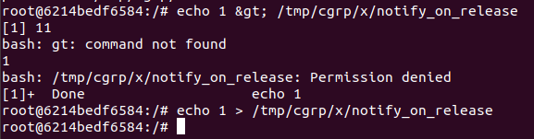

This can make system finding the container’s directory as specified in the /etc/mtab file on the host system.

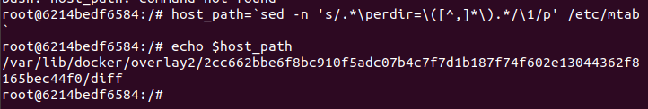

And placing the full path in the release_agent file inside the container.

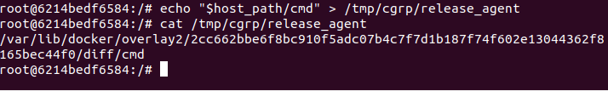

I write our /cmd script and execute by killing the cgroup’s tasks. it will execute the ps aux command and save its output into /output on the container

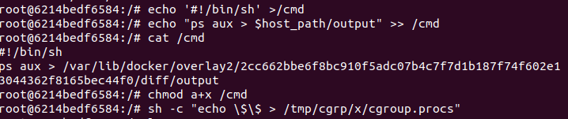

I can see the output file which lists the host system’s processes.

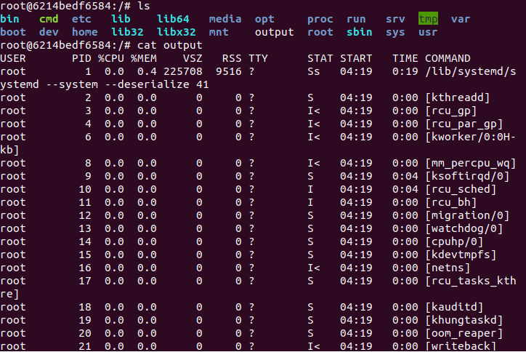

Using ps aux in docker directly will be like this.

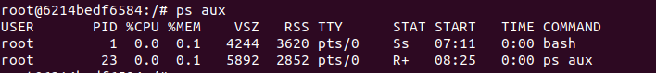

1. Trail of Bits. 2019. Understanding Docker Container Escapes. Trail of Bits. Accessed Oct. 20, 2020. https://blog.trailofbits.com/2019/07/19/understanding-docker-container-escapes/